1. **INTRODUCTION**
   1. *overview*
      * *Description of the project*

Project Description:

**Preparation and Maintanence of ZOHO Books for UrbanAura Interiors**

UrbanAura Interiors , a Interior Designing company uses Zoho books to effectively manage their financial processes, maintain accurate records, and make informed financial decisions. This integration enhances their overall business efficiency and contributes to their success in the interior design industry.

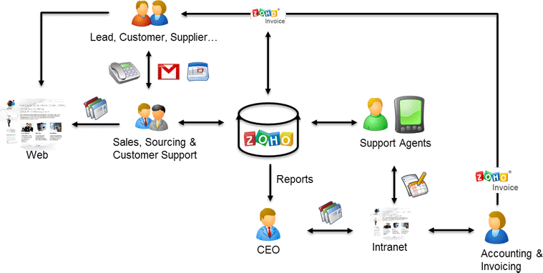

* 1. *Empathy map*

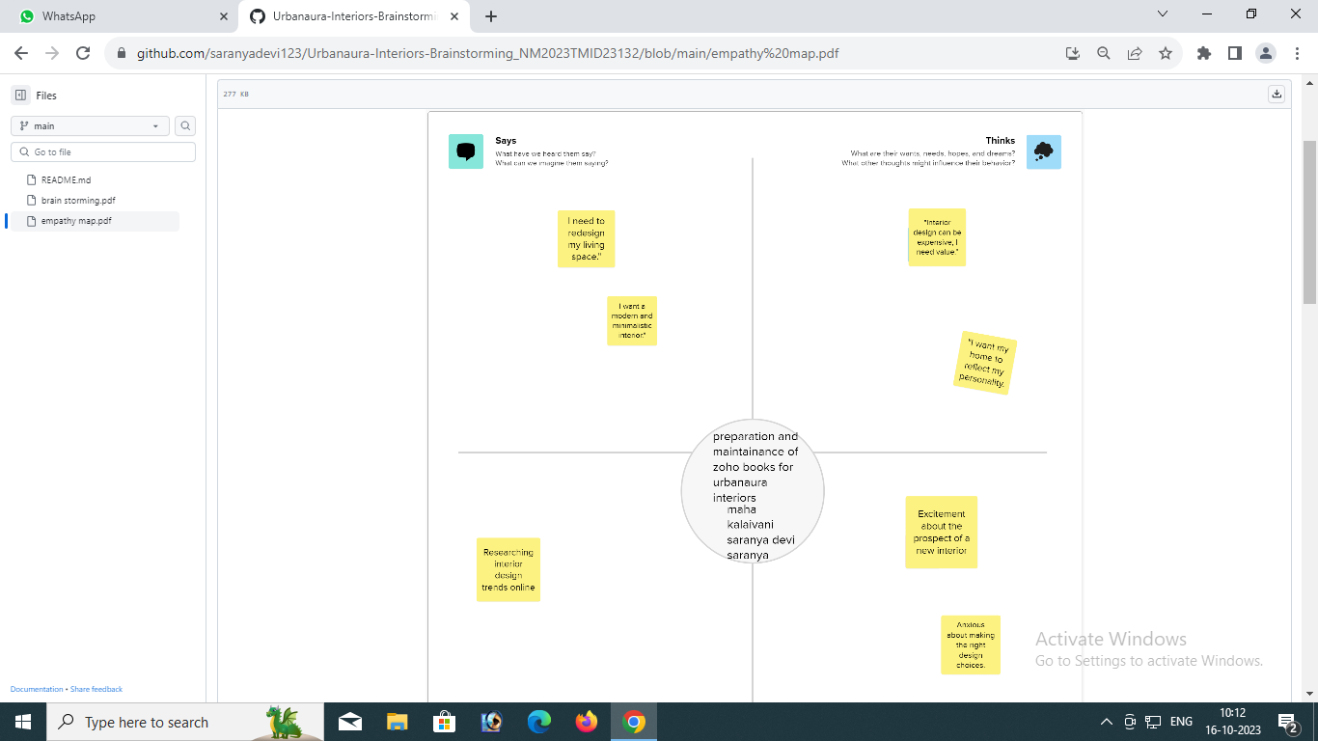

*Ideation & Brainstorming map*

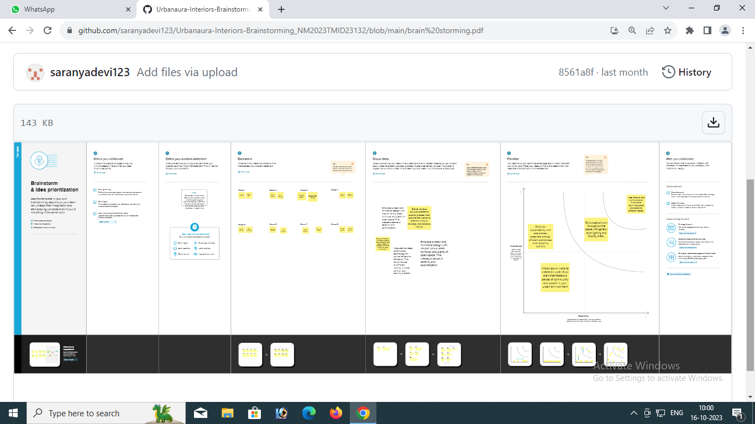

1. **Result Profit&loss**

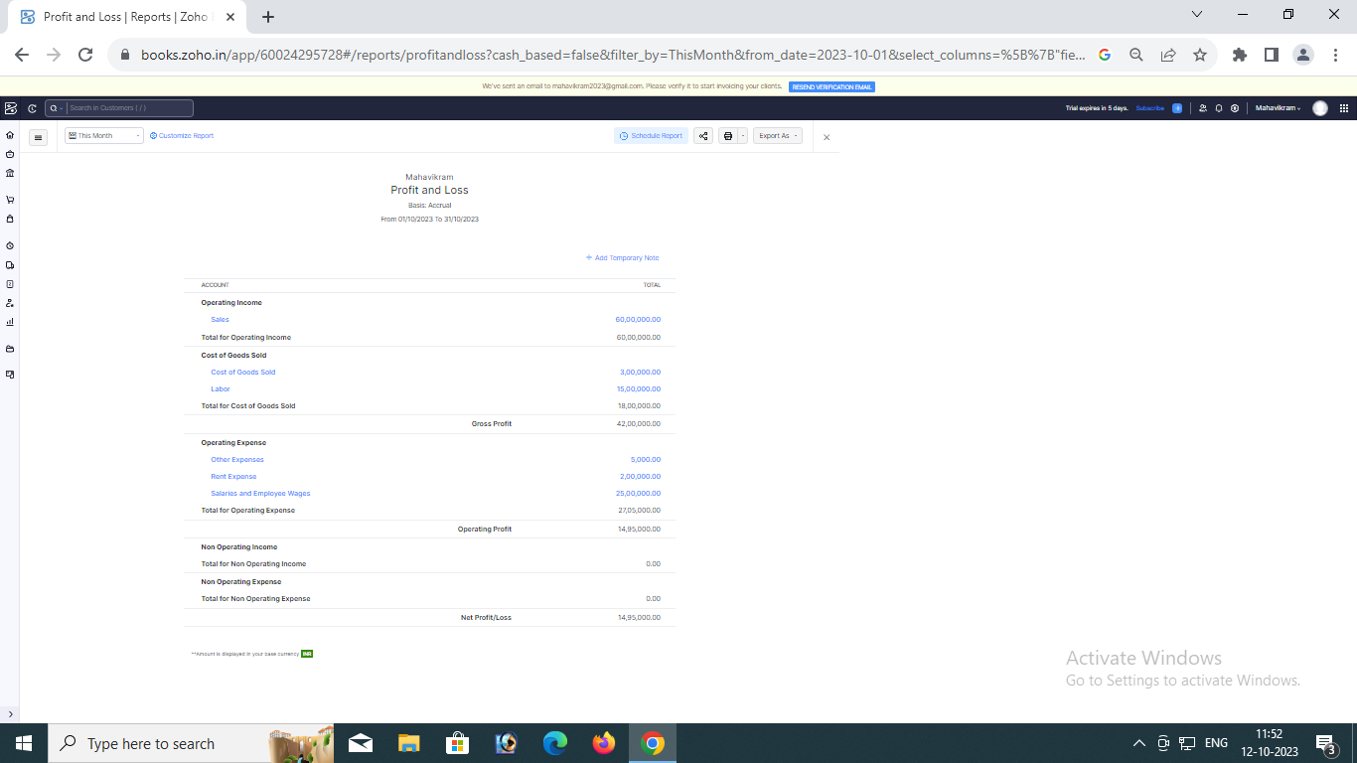

Balance sheet:

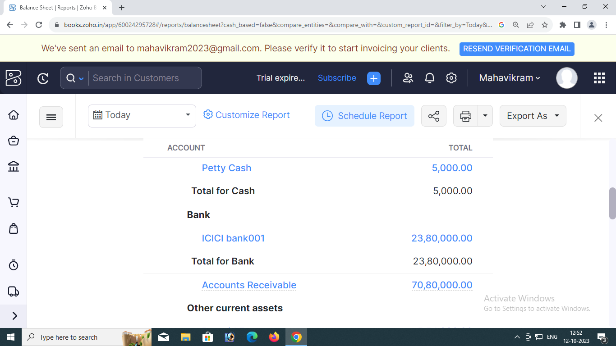

Purchase order:

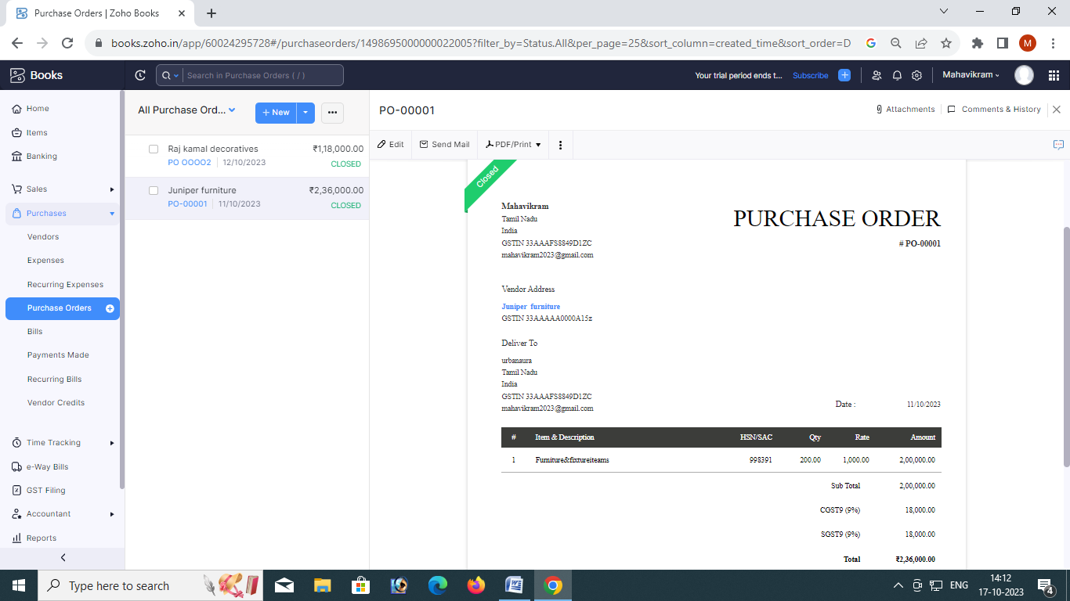

ADVANTAGES OF HEALTHHUB MEDICAL CLINIC:

OUR PROJECTS FALL UNDER A WIDE SPECTRUM OF SECTORS VARYING FROM RESIDENTIAL TO COMMERCIAL AND PUBLIC DEVELOPMENTS WITH THE MAIN GOAL

DISADVANTAGES OF HEALTHHUB MEDICAL CLINIC:

Transport facilitites of modern cities are highly developed

There is constant electrisitysupply living in cities experiencenc

*APPLICATIONS:*

*Urban aura interiors*

1. **Conclusion:**

The AURA Strategy is an intervention methodology which focuses on the regeneration of neighbourhoods or obsolete urban fabrics

The AURA Strategy is an intervention methodology which focuses on the regeneration of neighbourhoods or obsolete urban fabrics

1. **FUTURE SCOPE:**

its business scope includes **urban planning, architectural design, landscape design, interior design**, architectural engineering consulting,

The AURA Strategy is an intervention methodology which **focuses on the regeneration of neighbourhoods or obsolete urban fabrics**

**7.APPENDIX:**

<https://drive.google.com/file/d/16GjwYsEEwQ3Z8r9Z6ALom-32Mthr7Po0/view?pli=1>

DOCTYPE html>

<!—saved from url=(0087)https://

<[!github.com/asmku643mku643c1c31260/NM2023TMID22539/blob/main](https://github.com/asmku643mku643c1c31260/NM2023TMID22539.git)/profit_and_loss.pd f □

<html lang=”en” data-color-mode=”auto” data-light-theme=”light” data-dark-theme=”dark” data-a11y-animated-images=”system” data-a11y-link-underlines=”true”

data-turbo-loaded=””><head><meta http-equiv=”Content-Type” content=”text/html; charset=UTF-8”><style type=”text/css”>.turbo-progress-bar {

Position: fixed; Display: block; Top: 0;

Left: 0; Height: 3px;

Background: #0076ff;

z-index: 2147483647; transition:

width 300ms ease-out, opacity 150ms 150ms ease-in; transform: translate3d(0, 0, 0);

}

</style>

<link crossorigin=”anonymous” media=”all” rel=”stylesheet” href=”./NM2023TMID22539_profit_and_loss.pdf at main · asmku643mku643c1c31260_NM2023TMID22539 · GitHub_files/light-b92e9647318f.css”><link crossorigin=”anonymous” media=”all” rel=”stylesheet” href=”./NM2023TMID22539_profit_and_loss.pdf at main · asmku643mku643c1c31260_NM2023TMID22539 · GitHub_files/dark-5d486a4ede8e.css”><link data-color-theme=”dark_dimmed” crossorigin=”anonymous” media=”all” rel=”stylesheet” data-href=https://github.githubassets.com/assets/dark_dimmed-27c8d635e4e5.css><link data-color-theme=”dark_high_contrast” crossorigin=”anonymous” media=”all”

rel=”stylesheet”

data-href=https://github.githubassets.com/assets/dark_high_contrast-8438e75afd36.css><lin k data-color-theme=”dark_colorblind” crossorigin=”anonymous” media=”all” rel=”stylesheet” data-href=https://github.githubassets.com/assets/dark_colorblind-bf5665b96628.css><link data-color-theme=”light_colorblind” crossorigin=”anonymous” media=”all” rel=”stylesheet” data-href=https://github.githubassets.com/assets/light_colorblind-c414b5ba1dce.css><link data-color-theme=”light_high_contrast” crossorigin=”anonymous” media=”all” rel=”stylesheet”

data-href=https://github.githubassets.com/assets/light_high_contrast-e5868b7374db.css><lin k data-color-theme=”light_tritanopia” crossorigin=”anonymous” media=”all” rel=”stylesheet” data-href=https://github.githubassets.com/assets/light_tritanopia-299ac9c64ec0.css><link data-color-theme=”dark_tritanopia” crossorigin=”anonymous” media=”all” rel=”stylesheet” data-href=h[ttps://github.githubassets.com/assets/dark_tritanopia-3a26e78ad0ff.css>](https://github.githubassets.com/assets/light_high_contrast-e5868b7374db.css)

<link cros[sorigin=”anonymous” media=”all” rel=”stylesheet”](https://github.githubassets.com/assets/dark_tritanopia-3a26e78ad0ff.css) href=”./NM2023TMID22539_profit_and_loss.pdf at main · asmku643mku643c1c31260_NM2023TMID22539 · GitHub_files/primer-primitives-6143c8f97ed1.css”>

<link crossorigin=”anonymous” media=”all” rel=”stylesheet” href=”./NM2023TMID22539_profit_and_loss.pdf at main · asmku643mku643c1c31260_NM2023TMID22539 · GitHub_files/primer-d6dcdf72e61d.css”>

<link crossorigin=”anonymous” media=”all” rel=”stylesheet” href=”./NM2023TMID22539_profit_and_loss.pdf at main · asmku643mku643c1c31260_NM2023TMID22539 · GitHub_files/global-ab1c3e3e5644.css”>

<link crossorigin=”anonymous” media=”all” rel=”stylesheet” href=”./NM2023TMID22539_profit_and_loss.pdf at main · asmku643mku643c1c31260_NM2023TMID22539 · GitHub_files/github-757ef6ea9a38.css”>

<link crossorigin=”anonymous” media=”all” rel=”stylesheet” href=”./NM2023TMID22539_profit_and_loss.pdf at main · asmku643mku643c1c31260_NM2023TMID22539 · GitHub_files/code-71ecd5638fbf.css”>

<script type=”application/json”

id=”client-env”>{“locale”:”en”,”featureFlags”:[“failbot_handle_non_errors”,”geojson_azure_m aps”,”image_metric_tracking”,”turbo_experiment_risky”,”sample_network_conn_type”]}</scri pt>

<script crossorigin=”anonymous” defer=”defer” type=”application/javascript” src=”./NM2023TMID22539_profit_and_loss.pdf at main · asmku643mku643c1c31260_NM2023TMID22539 ·

GitHub_files/wp-runtime-86f14561f3b0.js.download”></script>

<script crossorigin=”anonymous” defer=”defer” type=”application/javascript” src=”./NM2023TMID22539_profit_and_loss.pdf at main · asmku643mku643c1c31260_NM2023TMID22539 ·

GitHub_files/vendors-node_modules_dompurify_dist_purify_js-64d590970fa6.js.download”>

</script>

<script crossorigin=”anonymous” defer=”defer” type=”application/javascript” src=”./NM2023TMID22539_profit_and_loss.pdf at main · asmku643mku643c1c31260_NM2023TMID22539 ·

GitHub_files/vendors-node_modules_stacktrace-parser_dist_stack-trace-parser_esm_js-node_ modules_github_bro-a4c183-18bf85b8e9f4.js.download”></script>

<script crossorigin=”anonymous” defer=”defer” type=”application/javascript” src=”./NM2023TMID22539_profit_and_loss.pdf at main · asmku643mku643c1c31260_NM2023TMID22539 ·

GitHub_files/ui_packages_soft-nav_soft-nav_ts-56133143b228.js.download”></script>

<script crossorigin=”anonymous” defer=”defer” type=”application/javascript” src=”./NM2023TMID22539_profit_and_loss.pdf at main · asmku643mku643c1c31260_NM2023TMID22539 ·

GitHub_files/environment-fc6543d75794.js.download”></script>

<script crossorigin=”anonymous” defer=”defer” type=”application/javascript” src=”./NM2023TMID22539_profit_and_loss.pdf at main · asmku643mku643c1c31260_NM2023TMID22539 ·

GitHub_files/vendors-node_modules_github_selector-observer_dist_index_esm_js-2646a2c53 3e3.js.download”></script>

<script crossorigin=”anonymous” defer=”defer” type=”application/javascript” src=”./NM2023TMID22539_profit_and_loss.pdf at main · asmku643mku643c1c31260_NM2023TMID22539 ·

GitHub_files/vendors-node_modules_primer_behaviors_dist_esm_focus-zone_js-d55308df50 23.js.download”></script>

<script crossorigin=”anonymous” defer=”defer” type=”application/javascript” src=”./NM2023TMID22539_profit_and_loss.pdf at main · asmku643mku643c1c31260_NM2023TMID22539 ·

GitHub_files/vendors-node_modules_github_relative-time-element_dist_index_js-99e288659 d4f.js.download”></script>

<script crossorigin=”anonymous” defer=”defer” type=”application/javascript” src=”./NM2023TMID22539_profit_and_loss.pdf at main · asmku643mku643c1c31260_NM2023TMID22539 ·

GitHub_files/vendors-node_modules_fzy_js_index_js-node_modules_github_combobox-nav_ dist_index_js-node_modu-344bff-91b70bb50d68.js.download”></script>

<script crossorigin=”anonymous” defer=”defer” type=”application/javascript” src=”./NM2023TMID22539_profit_and_loss.pdf at main · asmku643mku643c1c31260_NM2023TMID22539 ·

GitHub_files/vendors-node_modules_delegated-events_dist_index_js-node_modules_github_ auto-complete-element-81d69b-f766607dc0c8.js.download”></script>

<script crossorigin=”anonymous” defer=”defer” type=”application/javascript” src=”./NM2023TMID22539_profit_and_loss.pdf at main · asmku643mku643c1c31260_NM2023TMID22539 ·

GitHub_files/vendors-node_modules_github_filter-input-element_dist_index_js-node_module s_github_remote-inp-2e8678-d593bf262480.js.download”></script>

<script crossorigin=”anonymous” defer=”defer” type=”application/javascript” src=”./NM2023TMID22539_profit_and_loss.pdf at main · asmku643mku643c1c31260_NM2023TMID22539 ·

GitHub_files/vendors-node_modules_github_file-attachment-element_dist_index_js-node_m odules_primer_view-co-70ad06-9f8bb7e4a8fa.js.download”></script>

<script crossorigin=”anonymous” defer=”defer” type=”application/javascript” src=”./NM2023TMID22539_profit_and_loss.pdf at main · asmku643mku643c1c31260_NM2023TMID22539 ·

GitHub_files/github-elements-30961cfd137b.js.download”></script>

<script crossorigin=”anonymous” defer=”defer” type=”application/javascript” src=”./NM2023TMID22539_profit_and_loss.pdf at main · asmku643mku643c1c31260_NM2023TMID22539 ·

GitHub_files/element-registry-e5f51987a7c5.js.download”></script>

<script crossorigin=”anonymous” defer=”defer” type=”application/javascript” src=”./NM2023TMID22539_profit_and_loss.pdf at main · asmku643mku643c1c31260_NM2023TMID22539 ·

GitHub_files/vendors-node_modules_lit-html_lit-html_js-4ccebb6ebf7d.js.download”></script

>

<script crossorigin=”anonymous” defer=”defer” type=”application/javascript” src=”./NM2023TMID22539_profit_and_loss.pdf at main · asmku643mku643c1c31260_NM2023TMID22539 ·

GitHub_files/vendors-node_modules_github_mini-throttle_dist_index_js-node_modules_gith ub_alive-client_dist-bf5aa2-504c8d53fb8e.js.download”></script>

<script crossorigin=”anonymous” defer=”defer” type=”application/javascript” src=”./NM2023TMID22539_profit_and_loss.pdf at main · asmku643mku643c1c31260_NM2023TMID22539 ·

GitHub_files/vendors-node_modules_morphdom_dist_morphdom-esm_js-b1fdd7158cf0.js.do wnload”></script>

<script crossorigin=”anonymous” defer=”defer” type=”application/javascript” src=”./NM2023TMID22539_profit_and_loss.pdf at main · asmku643mku643c1c31260_NM2023TMID22539 ·

GitHub_files/vendors-node_modules_github_turbo_dist_turbo_es2017-esm_js-9a3541181451

.js.download”></script>

<script crossorigin=”anonymous” defer=”defer” type=”application/javascript” src=”./NM2023TMID22539_profit_and_loss.pdf at main · asmku643mku643c1c31260_NM2023TMID22539 ·

GitHub_files/vendors-node_modules_github_remote-form_dist_index_js-node_modules_scrol l-anchoring_dist_scro-52dc4b-e1e33bfc0b7e.js.download”></script>

<script crossorigin=”anonymous” defer=”defer” type=”application/javascript” src=”./NM2023TMID22539_profit_and_loss.pdf at main · asmku643mku643c1c31260_NM2023TMID22539 ·

GitHub_files/vendors-node_modules_color-convert_index_js-35b3ae68c408.js.download”></s cript>

<script crossorigin=”anonymous” defer=”defer” type=”application/javascript” src=”./NM2023TMID22539_profit_and_loss.pdf at main · asmku643mku643c1c31260_NM2023TMID22539 ·

GitHub_files/vendors-node_modules_primer_behaviors_dist_esm_dimensions_js-node_modu les_github_jtml_lib_index_js-a18147cea3a6.js.download”></script>

<script crossorigin=”anonymous” defer=”defer” type=”application/javascript” src=”./NM2023TMID22539_profit_and_loss.pdf at main ·

asmku643mku643c1c31260_NM2023TMID22539 ·

GitHub_files/vendors-node_modules_github_paste-markdown_dist_index_esm_js-node_mod ules_github_quote-select-581a1f-4a3074d34892.js.download”></script>

<script crossorigin=”anonymous” defer=”defer” type=”application/javascript” src=”./NM2023TMID22539_profit_and_loss.pdf at main · asmku643mku643c1c31260_NM2023TMID22539 · GitHub_files/app_assets_modules_github_details-dialog_ts-app_assets_modules_github_fetc h_ts-add1ab03ecb3.js.download”></script>

<script crossorigin=”anonymous” defer=”defer” type=”application/javascript” src=”./NM2023TMID22539_profit_and_loss.pdf at main · asmku643mku643c1c31260_NM2023TMID22539 · GitHub_files/app_assets_modules_github_updatable-content_ts-ui_packages_hydro-analytics

_hydro-analytics_ts-0a5a30c9b976.js.download”></script>

<script crossorigin=”anonymous” defer=”defer” type=”application/javascript” src=”./NM2023TMID22539_profit_and_loss.pdf at main · asmku643mku643c1c31260_NM2023TMID22539 · GitHub_files/app_assets_modules_github_onfocus_ts-app_assets_modules_github_sticky-scr oll-into-view_ts-c56a5dfc8975.js.download”></script>

<script crossorigin=”anonymous” defer=”defer” type=”application/javascript” src=”./NM2023TMID22539_profit_and_loss.pdf at main · asmku643mku643c1c31260_NM2023TMID22539 · GitHub_files/app_assets_modules_github_behaviors_task-list_ts-app_assets_modules_github

_sso_ts-ui_packages-7d50ad-9491f2be61ee.js.download”></script>

<script crossorigin=”anonymous” defer=”defer” type=”application/javascript” src=”./NM2023TMID22539_profit_and_loss.pdf at main · asmku643mku643c1c31260_NM2023TMID22539 · GitHub_files/app_assets_modules_github_behaviors_ajax-error_ts-app_assets_modules_gith ub_behaviors_include-2e2258-d77f85c54572.js.download”></script>

<script crossorigin=”anonymous” defer=”defer” type=”application/javascript” src=”./NM2023TMID22539_profit_and_loss.pdf at main · asmku643mku643c1c31260_NM2023TMID22539 · GitHub_files/app_assets_modules_github_behaviors_commenting_edit_ts-app_assets_modul es_github_behaviors_ht-83c235-f22ac6b94445.js.download”></script>

<script crossorigin=”anonymous” defer=”defer” type=”application/javascript” src=”./NM2023TMID22539_profit_and_loss.pdf at main · asmku643mku643c1c31260_NM2023TMID22539 ·

GitHub_files/behaviors-8e3546d05c82.js.download”></script>

<script crossorigin=”anonymous” defer=”defer” type=”application/javascript” src=”./NM2023TMID22539_profit_and_loss.pdf at main · asmku643mku643c1c31260_NM2023TMID22539 ·

GitHub_files/vendors-node_modules_delegated-events_dist_index_js-node_modules_github_ catalyst_lib_index_js-623425af41e1.js.download”></script>

<script crossorigin=”anonymous” defer=”defer” type=”application/javascript” src=”./NM2023TMID22539_profit_and_loss.pdf at main · asmku643mku643c1c31260_NM2023TMID22539 ·

GitHub_files/notifications-global-0104a8043aa4.js.download”></script>

<script crossorigin=”anonymous” defer=”defer” type=”application/javascript” src=”./NM2023TMID22539_profit_and_loss.pdf at main · asmku643mku643c1c31260_NM2023TMID22539 ·

GitHub_files/vendors-node_modules_optimizely_optimizely-sdk_dist_optimizely_browser_es

_min_js-node_modules-089adc-8794271c9a65.js.download”></script>

<script crossorigin=”anonymous” defer=”defer” type=”application/javascript” src=”./NM2023TMID22539_profit_and_loss.pdf at main · asmku643mku643c1c31260_NM2023TMID22539 ·

GitHub_files/optimizely-b8ae60018b11.js.download”></script>

<script crossorigin=”anonymous” defer=”defer” type=”application/javascript” src=”./NM2023TMID22539_profit_and_loss.pdf at main · asmku643mku643c1c31260_NM2023TMID22539 ·

GitHub_files/vendors-node_modules_virtualized-list_es_index_js-node_modules_github_tem plate-parts_lib_index_js-677582870bfd.js.download”></script>

<script crossorigin=”anonymous” defer=”defer” type=”application/javascript” src=”./NM2023TMID22539_profit_and_loss.pdf at main · asmku643mku643c1c31260_NM2023TMID22539 ·

GitHub_files/vendors-node_modules_github_remote-form_dist_index_js-node_modules_dele gated-events_dist_inde-c537341-13ba07af3b2c.js.download”></script>

<script crossorigin=”anonymous” defer=”defer” type=”application/javascript” src=”./NM2023TMID22539_profit_and_loss.pdf at main · asmku643mku643c1c31260_NM2023TMID22539 · GitHub_files/app_assets_modules_github_ref-selector_ts-cad36de2ca60.js.download”></scrip t>

<script crossorigin=”anonymous” defer=”defer” type=”application/javascript” src=”./NM2023TMID22539_profit_and_loss.pdf at main ·

asmku643mku643c1c31260_NM2023TMID22539 · GitHub_files/codespaces-d5d24842ceda.js.download”></script>

<script crossorigin=”anonymous” defer=”defer” type=”application/javascript” src=”./NM2023TMID22539_profit_and_loss.pdf at main · asmku643mku643c1c31260_NM2023TMID22539 ·

GitHub_files/vendors-node_modules_github_filter-input-element_dist_index_js-node_module s_github_mini-throt-08ab15-d50c69097a3e.js.download”></script>

<script crossorigin=”anonymous” defer=”defer” type=”application/javascript” src=”./NM2023TMID22539_profit_and_loss.pdf at main · asmku643mku643c1c31260_NM2023TMID22539 ·

GitHub_files/vendors-node_modules_github_file-attachment-element_dist_index_js-node_m odules_github_mini-th-55cf52-b2acd5425c7c.js.download”></script>

<script crossorigin=”anonymous” defer=”defer” type=”application/javascript” src=”./NM2023TMID22539_profit_and_loss.pdf at main · asmku643mku643c1c31260_NM2023TMID22539 ·

GitHub_files/repositories-b80504a04cf8.js.download”></script>

<script crossorigin=”anonymous” defer=”defer” type=”application/javascript” src=”./NM2023TMID22539_profit_and_loss.pdf at main · asmku643mku643c1c31260_NM2023TMID22539 ·

GitHub_files/vendors-node_modules_github_remote-form_dist_index_js-node_modules_dele gated-events_dist_inde-0e9dbe-6435366f0862.js.download”></script>

<script crossorigin=”anonymous” defer=”defer” type=”application/javascript” src=”./NM2023TMID22539_profit_and_loss.pdf at main · asmku643mku643c1c31260_NM2023TMID22539 ·

GitHub_files/topic-suggestions-2e55863e3751.js.download”></script>

<script crossorigin=”anonymous” defer=”defer” type=”application/javascript” src=”./NM2023TMID22539_profit_and_loss.pdf at main · asmku643mku643c1c31260_NM2023TMID22539 ·

GitHub_files/code-menu-6bd50a0647d6.js.download”></script>

<meta http-equiv=”x-pjax-version” content=”d98aab6b69dc43e4407b1369c7bbfcf76dfab2d839011937153201c9b943f42f” data-turbo-track=”reload”>

<meta http-equiv=”x-pjax-csp-version” content=”ee14a7165914197d62e19f664bfb961fcfdfc1ec31939a5c7b137fbab1751c87” data-turbo-track=”reload”>

<meta http-equiv=”x-pjax-css-version” content=”664233c3fea08fdf2ac6994c09da8d00c5e5f750fe523a7605f44e0aafe71afe” data-turbo-track=”reload”>

<meta http-equiv=”x-pjax-js-version” content=”dd74378fedb3de5476a9fb9b72cce29ed416c09618bddd59f59777f848393889” data-turbo-track=”reload”>

<style type=”text/css” id=”operaUserStyle”></style>

<script type=”application/javascript” src=”./NM2023TMID22539_profit_and_loss.pdf at main

· asmku643mku643c1c31260_NM2023TMID22539 · GitHub_files/react-lib-210c4b5934c3.js.download”></script><script

type=”application/javascript” src=”./NM2023TMID22539_profit_and_loss.pdf at main · asmku643mku643c1c31260_NM2023TMID22539 ·

GitHub_files/vendors-node_modules_primer_octicons-react_dist_index_esm_js-node_module s_primer_react_lib-es-3db9ab-5f4faa9f1811.js.download”></script><script type=”application/javascript” src=”./NM2023TMID22539_profit_and_loss.pdf at main · asmku643mku643c1c31260_NM2023TMID22539 ·

GitHub_files/vendors-node_modules_primer_react_lib-esm_Box_Box_js-96a44addc402.js.do wnload”></script><script type=”application/javascript” src=”./NM2023TMID22539_profit_and_loss.pdf at main · asmku643mku643c1c31260_NM2023TMID22539 ·

GitHub_files/vendors-node_modules_primer_react_lib-esm_Button_Button_js-node_modules

_primer_react_lib-esm_-f6da63-1976b80d3486.js.download”></script><script type=”application/javascript” src=”./NM2023TMID22539_profit_and_loss.pdf at main · asmku643mku643c1c31260_NM2023TMID22539 ·

GitHub_files/vendors-node_modules_primer_react_lib-esm_Truncate_Truncate_js-node_mod

ules_primer_react_lib—5d1957-92534314547a.js.download”></script><script type=”application/javascript” src=”./NM2023TMID22539_profit_and_loss.pdf at main · asmku643mku643c1c31260_NM2023TMID22539 ·

GitHub_files/vendors-node_modules_primer_react_lib-esm_Button_index_js-node_modules_ primer_react_lib-esm_O-279bf8-c9a61955d545.js.download”></script><script type=”application/javascript” src=”./NM2023TMID22539_profit_and_loss.pdf at main · asmku643mku643c1c31260_NM2023TMID22539 ·

GitHub_files/vendors-node_modules_primer_react_lib-esm_Text_Text_js-node_modules_pri mer_react_lib-esm_Text-85a14b-0f28951279b7.js.download”></script><script type=”application/javascript” src=”./NM2023TMID22539_profit_and_loss.pdf at main · asmku643mku643c1c31260_NM2023TMID22539 ·

GitHub_files/vendors-node_modules_primer_react_lib-esm_ActionList_index_js-535c8ee1ebe 8.js.download”></script><script type=”application/javascript” src=”./NM2023TMID22539_profit_and_loss.pdf at main · asmku643mku643c1c31260_NM2023TMID22539 ·

GitHub_files/vendors-node_modules_primer_react_lib-esm_ActionMenu_ActionMenu_js-2f0 8ef908241.js.download”></script><script type=”application/javascript” src=”./NM2023TMID22539_profit_and_loss.pdf at main · asmku643mku643c1c31260_NM2023TMID22539 · GitHub_files/vendors-